**REPRODUCTION IN FARM ANIMALS**

Reproduction is the production of a new generation of off springs from parents.

Farm animals reproduce sexually which involves the fusion of the male gametes (sperms) with the female gametes (ova) through the process of fertilization.

The ova are produced by ovaries while the sperms are produced by the testis.

**Efficient reproduction necessitates that;**

* The female produces normal number of healthy mature eggs
* Each of the eggs is capable of being fertilized by a normal spermatozoon.
* The female genital tract is healthy and normal, capable of nurturing the zygote during its development.
* The female is capable of producing normal healthy off springs.
* The male is able to produce sufficient number of healthy spermatozoa capable of fertilizing the egg(s) on mating or insemination.
* The male is in good physical condition to mate or give semen at frequent intervals.
* Mating or insemination takes place at the proper time when ovum and sperm are active and capable of fertilization.

**Terminologies related to reproduction**

1. Sperm; It refers to the male gamete that fuses with the egg (ovum) to form a zygote.
2. Ovum; This is a female gamete that fuses with the sperm to form a zygote.
3. Zygote; This is a cell produced by the union or fusion of the sperm and ovum.
4. Semen; It is a mixture of sperms and fluids produced by the prostate gland and seminal vesicles.
5. Puberty; This is a stage at which a farm animal attains sexual maturity and becomes sexually active.
6. Reproductive efficiency; It refers to the regularity with which the herd/flock is able to bring out new off-springs.
7. Fertility; It refers to the ability of the animal to reproduce.

**Reproductive systems of livestock**

**Parts of a reproductive system of a male farm animal (bull)**

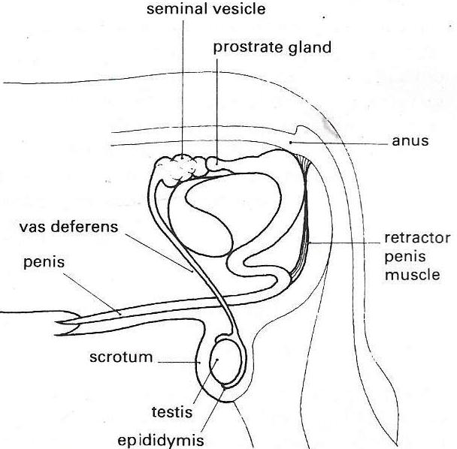

**Functions of the parts**

1. **Testes:** These are the primary organs of reproduction in the male animal. They are located in the scrotum.

They are made up of seminiferous tubules that produce/manufacture the sperms.

**Functions**

* They produce spermatozoa
* They secret the male sex hormone called testosterone/Androgen which is responsible for controlling male secondary sexual characteristics such as tusks in boars, combs and spurs in cocks.

1. **Scrotum:** It is a double sac containing the testes which is a pouch formed by the weight of the testes.

* It supports the testes.
* Protects the testes from mechanical damage.
* Regulates and maintains the temperature suitable for production of sperms.

1. **Epididymis:** It is a highly coiled tubule connected to the testis.

It stores the sperms and allows them to mature further before ejaculation.

1. **Sperm duct/vas deferens:** transports sperms from the epididymis to the urethra.
2. **Prostate gland:** provides an alkaline secretion that neutralizes the seminal plasma.
3. **Seminal vesicles:** they provide the largest portion of the seminal fluid, mainly nutrients.
4. **Cowper’s gland:** (Bulbo – urethral glands)

They secret bulbo-urethral fluid that is clear mucus into the urethra for cleaning the urethra free of urine/cleanse the urethra.

The combined secretions of the above named glands are known as seminal plasma or accessory fluids which serve the following functions;

* Cleanses the urethra prior to ejaculation
* Activates the spermatozoa
* Provides nutrients for spermatozoa
* Protect sperms against any toxic substances
* Provide energy to sperms.
* A medium for transportation of sperms in the urethra
* Dilute the sperms thus increasing the volume of the semen
* Neutralizes the acids in the vagina and urethra
* Lubricate the urethra and vagina to allow smooth intercourse and movement of sperms along the urethra.

1. **Urethra:** It is a duct or passage that runs through the penis, connecting the bladder to the external orifice at the end of the penis.

The urethra has two functions;

* Carries urine for excretion from the bladder to the external orifice/opening.
* Transports semen from the testes to the reproductive tract of the female.

1. **Penis:** It is a spongy erectile tissue that becomes filled with blood during erection.

* It is a copulatory/mating organ which releases sperms into the vagina
* Organ of passing urine.

1. **Retractor penis muscle;** enables the penis to be drawn and extended during erection.
2. **Sheath;** protects the penis from damages.

**Reproductive system of a female farm animal (cow)**

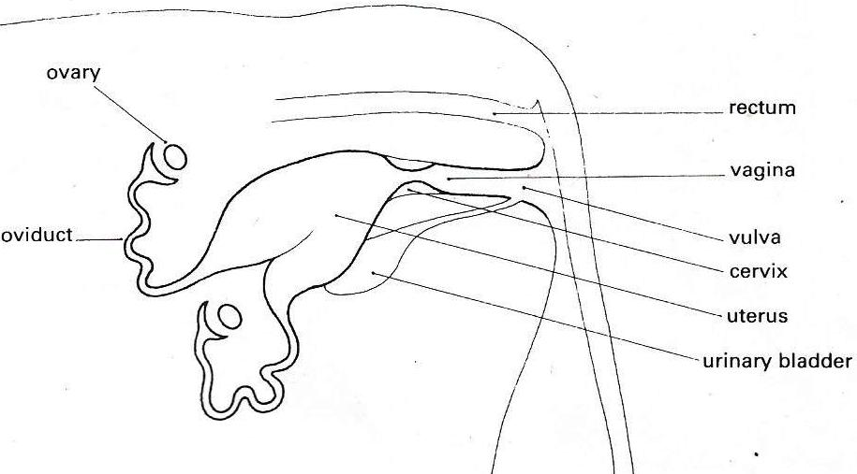

**Functions of the parts**

1. **Ovaries**

These are the primary reproductive organs of the female. Their growth and development is controlled by hormones from the anterior pituitary gland.

The ova/eggs develop in structural units called **follicles** and usually each follicle contains one ovum.

As the follicles increase in size and protrude above the surface of the ovary they are called **Graafian follicles**.

After the releases of the ovum the empty follicle may develop into the **corpus luteum**. The corpus luteum produces a hormone called progesterone.

**Functions**

* Produce female gametes (eggs or ova)
* Secret female hormones (oestrogen, progesterone and relaxin which regulate the sexual cycle.

1. **Infundibulum**

This is a funnel-shaped end of the fallopian tube, which lies below and partially covers the ovary.

**Function:** Receives the ova/eggs that are released during ovulation.

1. **Fallopian tubes/oviducts**

* Provide connection between the infundibulum and the uterus
* The oviducts with a ciliated inner surface transport the ova to the uterus.
* Fertilization normally takes place in the upper part of the fallopian tube.

1. **Uterus/womb:**

* It is made up of the body (corpus) and the neck (cervix).
* The outer layer/surface of the uterus wall (the myometrium) contains smooth muscle which contracts strongly during birth. The inner layer (endometrium) contains many glands and many blood vessels. These glands secret/produce secretion that is seen coming out of the vulva during heat period (oestrus).
* The endometrium also provides nutrition to the developing embryo prior to implantation.

**Functions**

* It is a site for implantation or development of the embryo.
* Also produces prostaglandin F2α.

1. **Cervix**

This is a thick walled muscular neck of the uterus.

It consists of a strong muscular sphincter muscle which is tightly closed during pregnancy. The sphincter muscle relaxes only during oestrus and parturition.

**Functions**

* It connects the uterus and vagina
* It offers protection to the feotus
* Consists of a stronger muscular sphincter which keeps the opening closed during pregnancy and anoestrus period.
* The muscular sphincter relaxes only during oestrus (heat) and parturition.

1. **Vagina;** This is posterior part of the female reproductive tract

* Serves as copulatory organ
* It acts as a birth canal. The lining of the vagina is folded and stretches during birth to allow passage of the baby.
* It passes out urine

1. **Vulva**

* It is the posterior opening of the female genital tract. It forms a loose seal between the internal and external environments.

At the onset of each period, the vulva becomes enlarged and filled with blood. Farmers use this condition of the vulva as a sigh of heat.

**HORMONES INVOLVED IN REPRODUCTION OF FARM ANIMALS**

A hormone is an organic chemical substance secreted by a gland or organ in one part of the body that controls chemical or biological reactions in another part of the body.

The hormones that control reproduction in farm animals are divided into two groups namely;

1. **Gonadotrophic hormones**

These are hormones that are secreted by the anterior pituitary gland under the influence of releasing factors from the part of the brain known as the hypothalamus.

Examples include;

* Follicle stimulating hormone (FSH)
* Luteinizing hormone (LH)
* Prolactin
* Oxytocin
* Lactogen

1. **Gonadal/sex hormones**

These are hormones which are secreted by gonads (ovaries and testes)

Examples include

* Testosterone/Androgen
* Oestrogen
* Progesterone
* Luteotrophic hormone

**MALE HORMONES**

Sexual maturity in the young is only achieved if the gonadotrophic hormones are produced in sufficient quantities.

1. **Follicle Stimulating Hormone;** induces the development of seminiferous tubules in the testes and is therefore concerned with the production of spermatozoa.
2. **Luteinizing Hormone;** stimulates the development of interstitial cells which are responsible for the production of the gonadal hormone or androgen. However, Follicle Stimulating Hormone, Luteinizing Hormone and testosterone are all required for the complete development of seminiferous tubules.
3. **Testosterone;** the predominant androgen in the adult male animals plays an important role in;

* Stimulating libido (sex desire)
* Inducing puberty
* Controlling development and maintenance of the entire male reproductive tract.
* Developing secondary sexual characteristics such as massive head and shoulders of bulls, horns in some breeds of rams, tusks in boars, combs and spurs in cocks, general tendency for less fat and marbling of muscle, little or no mammary development.

**FEMALE HORMONES**

1. **Follicle stimulating hormone: (FSH)**

It is secreted by the anterior pituitary gland.

**Functions**

* Stimulates the development and growth of the follicles in the ovary
* Stimulates the follicles to increase production of oestrogen together with luteinizing hormone.
* Initiates ovulation in a cow.

1. **Luteinizing hormone (LH)**

It is secreted by anterior pituitary gland

**Functions**

* Responsible for ovulation. It causes the rapture of the graafian follicle so as to release the ovum.
* Causes formation of corpus luteum in the cavity left after ovulation.
* Responsible for secretion of progesterone by the corpus luteum.
* Initiates secretion of milk into the alveoli of the udder.

1. **Oestrogen**

In non-pregnant female animals the main source is the ovarian follicles.

In pregnant animals, the placenta is the main source.

Diethylstilbestrol is the most common of a group of synthetic oestrogens.

It is used in hormonal treatments, as a feed additive for fattening animals, and to produce abortion in domestic animals.

**Functions**

* It is responsible for onset of oestrus or heat signs.
* Responsible for the development of secondary sexual characteristics e.g. mammary glands.
* It stimulates the growth and repair of uterine walls.
* It stimulates growth of the duct system in the udder.
* Responsible for the development and cycle changes of female tubular genital tract.

1. **Progesterone:**

It is also called the pregnancy hormone.

It is secreted by the remains of the graafian follicles in the ovary i.e. a yellow body (corpus luteum).

**Functions**

* Develops the uterus for implantation of the zygote (in presence of oestrogen).
* It maintains pregnancy
* Induces the development of glandular tissue in the mammary glands and uterus.
* Inhibits ovulation by direct action on the ovary or by suppression of the Luteinizing Hormone output.
* It facilitates production of uterine milk.

1. **Relaxin**

It is secreted by corpus luteum during late pregnancy and placenta.

**Function**

Relaxes the pelvic ligaments to facilitate parturition (achieved in presence of oestrogen)

1. **Prostaglandins F2α**

It is secreted by placenta, uterus.

**Function**

It causes the lysis of the corpus luteum and hence a fall in progesterone concentration.

1. **Oxytocin**

It is secreted by anterior pituitary gland.

**Functions**

* Promotes sperm transport in the female animal.
* It stimulates milk letdown.
* It causes contraction of the uterus muscles (labour) during parturition.

1. **Lactogen**

It is secreted by the pituitary gland

**Function**

It initiates milk production.

1. **Prolactin**

It is secreted by the pituitary gland

**Functions**

* Promotes the development of the mammary glands.
* It initiates milk production by the mammary glands after parturition.
* It maintains continued milk production until drying off.

**PUBERTY IN FARM ANIMALS**

Puberty is the stage of life in which animals reach sexual maturity.

At this stage the secondary sexual characteristics become visible.

The first oestrus in the female occurs at this stage.

Puberty is initiated by an increase in the concentration of gonadotrophic hormones.

**Factors that influence the onset of puberty in farm animals**

1. Weight of the animal: Animals tend to reach puberty at a certain critical weight.
2. Age of the animal: animals tend to reach sexual maturity at a certain average age that is typical for a particular breed.
3. Breed (Heredity): some breeds of animals are faster growing than others and so tend to reach puberty earlier.
4. Nutrition/level of feeding: well fed animals reach sexual maturity earlier than poorly fed animals.
5. Heterosity: Hybrid animals reach puberty earlier than pure breeds.
6. Level of hormones produced: the onset of puberty is triggered by the release of a certain quantity of gonadotrophic hormone. Some animals produce higher amounts of these hormones than other animals of same species. Such animals reach puberty earlier than others.
7. Housing or stock density: animals in congested quarters take longer to reach puberty because of the stress imposed on them by the environment.
8. Presence or absence of mature male animals; female animals exposed to males tend to reach puberty earlier than those isolated from males.

**OESTRUS CYCLE**

This is the interval between two successive heat periods.

It also refers to the period from the beginning of one heat to the beginning of the next.

The climax of the oestrus cycle is the release of ova (ovulation).

The oestrus cycle is divided into several phases.

1. **Proestrus (coming into heat period)**

This is the first stage of oestrus cycle and it is the building up phase in preparation for oestrus. Before the onset of oestrus, the ovary produces increasing quantities of oestrogen under the influence of FSH and LH. Oestrogen causes development of the uterus, vagina, oviducts and development of mammary glands and ovarian follicles.

1. **Oestrus (heat)**

This is a period when the female animals are in a proper condition for mating.

1. **Metoestrus**

Period just after ovulation/post ovulatory phase during which corpus luteum functions.

During this period there is a decrease in oestrogen and an increase in progesterone produced by corpus luteum.

Progesterone prevents the development of any other follicle and occurrence of further oestrus periods. The animal will no longer stand for the male.

1. **Dioestrus**

A period between two heats.

If conception doesn’t occur during metoestrus, dioestrus follows.

**Lactation anoestrus**

This is a phase of sexual inactivity that usually follows parturition in farm animals.

During lactation, the presence of certain hormones such as prolactin suppresses normal sexual behaviour in females.

Sometimes however, the animal may show signs of heat (post partum heat) though no ovulation occurs hence rendering animals infertile.

**Ways of reducing lactational anoestrus**

* Giving animals adequate and well balanced feeds to enable them return to heat earlier.
* Early weaning of youngones to reduce production of prolactin that suppresses normal oestrus.
* Treating animals with oestrogen to induce heat.
* Introduction of mature males to the females. The males produce hormones that induce heat in females.
* Introduction of creep feeds to the young to reduce suckling pressure on the mother and reduce the suckling stimulus responsible for release of prolactin.

**Hormonal change during oestrus cycle**

* The cycle starts with release of follicle stimulating hormone by the pituitary gland. FSH induces the graafian follicles to begin growing and also to produce oestrogen hormone.
* Oestrogen will stop production of FSH by the pituitary gland and induces the production of luteinizing hormone (LH).
* Luteinizing hormone (LH) will cause rapid growth of the follicles and leads to ovulation. After ovulation, it also stimulates the remains of the graafian follicle to become filled with a yellow pigment and form a yellow body, the corpus luteum.

The corpus luteum produces progesterone hormone.

* Progesterone develops the uterus for implantation of the zygote.

It also inhibits production of LH and FSH ensuring that there is no more oestrus. If pregnancy occurs, the corpus luteum persists and produce more progesterone. If pregnancy does not occur, another hormone produced by the uterus known as prostaglandin F2α triggers degeneration of the corpus luteum, so there will be no more progesterone to inhibit production of FSH and the cycle will begin again.

**Optimum time of service**

1. Cow: Just before the middle of oestrus to the end of oestrus.
2. Ewe: 18 – 24 hours after the onset of oestrus
3. Sow: 12 – 30 hours after the onset oestus
4. Mare: 3 – 4 days before end of oestrus or second or third day of oestrus.

**Signs of heat/oestrus**

1. **Cow**

* Loss of appetite
* Smelling (sniffing) other cows
* Bellowing i.e. making undue noise
* Stands to be mounted by the bull without moving away.
* Allowing other cows to mount her.
* Attempting to mount other cows/riding other cows
* Dilated pupil of the eye
* Clear mucus/slimy discharge from the vulva
* Reduction in milk yield in lactating cows.
* Restless behavior/nervousness
* Twitches the tail and switches the tail to one side exposing the vulva.
* The cow becomes unusually affectionate, licks others and seeks association with others
* Rise in body temperature
* Frequent urination
* The vulva swells and turns red.

1. **Sow**

* Swelling of the vulva and turns red.
* Mounting other pigs
* Restlessness/walking around enclosure
* Frequent urination
* Twitching the tail frequently.
* Loss of appetite
* Allowing other pigs to mount it.
* Stands still when pressed/touched on the back.
* Slight rise in body temperature
* Graunting i.e. making noise
* Clear mucus at the vulva
* Seek out the boar

1. **Ewe**

* Seek out the male, rub neck and body against him.
* Sniff his genitalia and rapidly shake her tail.
* Stand quietly and allow the ram to tease and mount her.
* Enlarged vulva
* Flow of clear thin mucus may be seen.

1. **She-goat**

* Restlessness
* Wagging of the tail
* Swollen and reddened vulva
* Muscles on either side of the tail slacken.

**Methods of heat detection:**

1. Observation of the animals for outward signs of heat.
2. Measuring the level of progesterone in milk. Low levels could indicate heat. If the level is high the animal is already pregnant.
3. Use of kamar heat mount detector; a detector filled with a red dye is glued on to the skin of the cow covering the tail base. When the cow wearing the detector is mounted, the pressure from the brisket of the bull makes the dye to come into contact with the skin of the cow and can be detected from a distance.
4. Measuring the electrical resistance of the mucus secreted around the cervical opening.

If the animal is on heat, there is a reduction in the electrical resistance of the mucus.